**STATIC CHATBOT**

*A*

*Mini Project Report*

*Submitted in partial fulfilment of the*

*Requirements for the award of the Degree of*

**BACHELOR OF ENGINEERING**

IN

**INFORMATION TECHNOLOGY**

By

**PABBA SURAJ 1602-17-737-052**

**PISARI JACOB 1602-17-737-013**

**YUKTA SHARMA 1602-17-737-045**



**Department of Information Technology**

**Vasavi College of Engineering (Autonomous)**

**(Affiliated to Osmania University)**

**Ibrahimbagh, Hyderabad-31**

**2018**

**Vasavi College of Engineering (Autonomous)**

**(Affiliated to Osmania University)**

**Hyderabad-500 031**

**Department of Information Technology**



**DECLARATION BY THE CANDIDATES**

             We, P.SURAJ, P.JACOB, YUKTA SHARMA**,** bearing hall ticket numbers, 1602-17-737-052, 1602-17-737-013,1602-17-737-045 respectively, hereby declare that the project report entitled “STATIC CHATBOT”Department of Information Technology, Vasavi College of Engineering, Hyderabad, is submitted in partial fulfilment of the requirement for the award of the degree of **Bachelor of Engineering** in **Information Technology**

              This is a record of bonafide work carried out by us and the results embodied in this project report have not been submitted to any other university or institute for the award of any other degree or diploma.

**PABBA SURAJ**

**1602-17-737-052**

**PISARI JACOB**

**1602-17-737-013**

**YUKTA SHARMA**

**1602-17-737-045**

(Faculty In-Charge)                  (Head,Dept of IT)

CONTENTS

1.Introduction 1

1.1 Purpose 3

1.2 Scope 3

2.Project description 4

3.Technology 4

3.1 Overview of technology used 4

3.2 Software Requirements 5

4.Code Templates 5

MODULE 1 9

MODULE 2 9

MODULE 3 10

MODULE 4 11

MODULE 5 12

MODULE 6 12

MODULE 7 14

MODULE 8 16

MODULE 9 19

MODULE 10 20

5.Output Screens 23

6.Conclusion and Future Scope 28

# 1.Introduction

Generally speaking a bot is any software that performs an automated task, however we are interested in the class of bots that live online in chat platforms or on social media called chatbots.

In this context there are many possible definitions and some confusion about what a bot is. This is partly because there are so many varied use cases for bots and these influence what people perceive a chatbot to be.

The most intuitive definition is that a bot is software that can have a conversation with a human. For example a user could ask the bot a question or give it an instruction and the bot could respond or perform an action as appropriate.

This definition however often leads to two potential misconceptions. The biggest misconception that arises is that a chatbot is a bot that converses with a human in the way that another human would converse with a human. Software or even a robot (the digital part of the robot is of course software) that communicates with a human in natural language is not difficult to imagine. Science fiction is full of examples.

While this may the end goal, this is simply not possible using the current technology. Not only is it not possible, it often leads to unrealistic expectations regarding the chatbots capabilities and inevitable frustrations when those expectations are not met.

The second misconception is that a chatbot communicates using only text or voice. Actually chatbots allow users to interact with them via graphical interfaces or graphical widgets, and the trend is in this direction. Many chat platforms including WeChat, Facebook Messenger and Kik allow web views on which developers can create completely customized graphical interfaces.

It’s true that, the lines between applications and chatbots can become a little bit blurred if chatbots interact via a user interface. A chatbot however can be differentiated from an app in the way that the interactions with the bot take place, more or less sequentially (as a conversation), and the bot is used inside a chat app.

Another obvious way in which a chatbot is different from an app is a little more reminiscent of the science fiction example, and that is the chatbot as metaphor for an automated agent. A chatbot unlike an app has a an “identity” that is actually separate from its interaction with the user. This is in the same way that the human agent exists independently of their interaction with customers. This metaphor can be extended to the point where a single chatbot could interact with the customer over several different communication channels.

In short a chatbot is another way of humans interacting with software. While there are overlaps with functionality offered by websites and apps, interacting with a chatbot is different to interacting with a website or with an app.

It is true that in some sense messaging platforms are becoming universal mobile apps or app portals. Businesses want to find ways to deliver their messages and services in the place that the consumers are, which is on chat platforms. Chatbots give them a way to do this.

## 1.1 Purpose

We see chatbots in every nook and corner of the Internet world. Every chatbot is based on a different kind of technology with as many functionalities as a human brain may think of to be possible.

But the sole purpose of our project is to get into this competitive world of new technologies and softwares with baby steps. Creating and demonstrating a basic chatbot using C language which will be a stepping stone in our research and urge to develop a completely professional chatbot in the forth coming future.

## 1.2 Scope

Our project is just a small step towards the creation of a ultra cool chatbot with a lot of functionalities. Our project has got a huge scope in present and as well as the forth future, where each and every person will be having their own chatbots which do things for them and on behalf of them.

Our project can be done in many other programming languages or softwares which can avail functionalities such a voice, motion sensing, image processing and many more…For example our project can be done in Python where voice is one of the basic functionalities given to the program.

Our current project has got basic functionalities such as it can play games, chat with you and many more…..but the functionalities are pretty basic, so there is a great scope for our project to develop in all directions.

# 2.Project description

Our project “Demonstrates” a ‘Chatbot’ using C language. The chatbot can play games with you or it will let you play games with another user. It can also “chat” with you by answering the ‘predefined’ questions already given to it. It can remember things such as ‘wake up early tomorrow’, ‘remind mom to take tablets on time’ and it will remind whenever you ask it to display. It consists of 4 basic games namely ‘hand cricket’, ‘baseball’, ‘rock, paper and scissors’, ‘guess the number’, which can be played with the bot with the system aka Chatbot or it will let you play with another user.

# 3.Technology

## 3.**1 Overview of technology used**

**C** is a computer programming language developed in 1972 by **Dennis M. Ritchie** at the Bell Telephone Laboratories to develop the UNIX Operating System. C is a simple and **structure oriented** programming language.

C is also called **mother Language** of all programming Language. It is the most widely used computer programming language, This language is used for develop system software and Operating System. All other programming languages were derived directly or indirectly from C programming concepts.

In the year 1988 'C' programming language standardized by ANSI (American national standard institute), that version is called **ANSI-C**. In the year of 2000 'C' programming Language standardized by 'ISO' that version is called C-99.

C Language is mainly used for

* Design Operating system
* Design Language Compiler
* Design Database
* Language Interpreters
* Utilities
* Network Drivers
* Assemblers

## 3.2 **Software Requirements**

Any basic C compiler such a GCC compiler or Code Blocks software or any other which supports getch() function.

# 4.Code Templates

* The “HEART OF THE BOT”, a program which encloses all modules in it as follows

#include <stdio.h>

#include <conio.h>

#include <stdlib.h>

#include <string.h>

#include "guess.h"

#include "mulc.h"

#include "cric.h"

#include "bsb.h"

#include "mulb.h"

#include "mulr.h"

#include "rps.h"

#include "mguess.h"

#include "clear.h"

void games()

{

int n;

do

{

printf("\n1.Guess The Number\n2.Cricket\n3.Multiplayer Cricket\n4.BaseBall\n5.Multiplayer Baseball\n6.Rock Paper Scissor\n7.Multiplayer Rock Paper Scissor\n8.MultiPlayer Guess The Number");

printf("\n Enter Your Choice");

scanf("%d",&n);

switch(n)

{

case 1://clrscr();

system("cls");

guess();

break;

case 2://clrscr();

system("cls");

cric();

break;

case 3://clrscr();

system("cls");

mulc();

break;

case 4://clrscr();

system("cls");

bsb();

break;

case 5://clrscr();

system("cls");

mulb();

break;

case 6://clrscr();

system("cls");

rps();

break;

case 7://clrscr();

system("cls");

mulr();

break;

case 8://clrscr();

system("cls");

mguess();

break;

default:

printf("\n Sorry!We Have Designed Only 8 Games");

}

}while(n<=8);

}

int getInput(char input[500])

{

char array[500],c;

FILE *fp=fopen("data.txt", "r+");

if(!fp)

{

printf("ERROR: No Directory To Read Answers");

}

else if(strcmp(input,"remember")==0)

{

FILE *fp1=fopen("remember.txt","w");

int n1;char rem[1000];

printf("how many things\n");

scanf("%d",&n1);

fputs(" These were the THINGS TO REMEMBER:",fp1);

for(int i=0;i<n1;i++)

{

scanf("%s",&rem);

fputs("\n",fp1);

fputs(rem,fp1);

}

fclose(fp1);

}

else

{

if(strcmp(input,"games")==0)

{

games();

}

if((strcmp(input,"did_i_say_u_to_remember_anything")==0)||(strcmp(input,"chitti")==0))

{

fp=fopen("remember.txt","r+");

c = fgetc(fp);

for(c='\n';c!=EOF;)

{

printf ("%c", c);

c = fgetc(fp);

}

exit(0);

fclose(fp);

}

while(!feof(fp))

{

fgets(array,128,fp);

if(strncmp(array,input,strlen(input))==0)

{

fgets(array,128,fp);

printf(">>BOT: %s\n",array);

}

}

}

return 0;

}

int main()

{

char input[500],prev[500],name[200];

clrscr();

printf("\n\nHello, Welcome\nThis is chatbot v1.0\n");

printf("\nEnter your name please:");

scanf("%s",&name);

do

{

printf(">>%s: ",name);

scanf("%s",&input);

getInput(input);

}

while(1);

return 0;

}

## MODULE 1

* The following included content is of data.txt which acts as an aid to the program by providing the predefined questions and answers to the chatbot.

hello

hi

how_are_you

I_dont_have_feelings

who_made_you

Team_RAPTORS

what_are_you

A_A.I_program_made_in_c

tell_me_more

I_can_remember_things,i_can_play_games_with_u

are_you_real

I_am_NOT.

what_is_your_name

I_am_"Mr.Underscore"

what's_your_age

10_days_old

where_do_you_live

In_the_hard_drive,I_feel_comfortable_and_safe_there.

how_can_you_help_me

I_can_"remember"_things,I_can_play_games

which_languages_do_you_speak

English

are_you_doing_ok

I_am_high_and_I_am_doing_great.

what_time_is_it

The_time_doesn't_matter_because_timing_matters.

your_hobbies_are

Non_stop_chatting_as_I_am_a_chatbot.

what_do_you_look_like

I_look_black_as_your_screen_is_one.

age

10_days_old

## MODULE 2

* This module encloses code of clearing the screen and displaying hello each and every time when it is invoked.

void clrscr()

{

system("@cls||clear");

printf("H H EEEEE L L OOO | | | | | | |\n");

printf("H H E L L O O | | | | | | |\n");

printf("H H E L L O O | | | | | | |\n");

printf("HHHHH EEEEE L L O O | | | | | | |\n");

printf("H H E L L O O | | | | | | |\n");

printf("H H E L L O O | | | | | | |\n");

printf("H H EEEEE LLLLL LLLLL OOO . . . . . . .\n");

}

## MODULE 3

* This module encloses the code of “ROCK PAPER SCISSORS” game(with the bot).

//RoCk Paper Scissor

void rps();

void rps()

{

printf("\nYou Have Choosen Rock Paper Scissor to Play");

int a,r,counts=0,countU=0,i;

printf("\n0.Rock\n1.Paper\n2.Scissor");

printf("\n You Can Play 10 Times");

for(i=0;i<=9;i++)

{

a=rand()%3;

printf("\n Enter your Choice");

scanf("%d",&r);

if(a==r)

printf("\n Draw");

else if((a==0&&r==1)||(a==1&&r==2)||(a==2&&r==0))

{

printf("\n Player Wins");

countU++;

}

else if(a==1&&r==0||a==2&&r==1||(a==0&&r==2))

{

printf("\n System Wins");

counts++;

}

}

printf("\n Score of \nSystem=%d\nPlayer=%d",counts,countU);

if(countU>counts)

printf("\n Hurrah!You are The Winner");

else if(counts>countU)

printf("\n Better Luck Next Time");

else

printf("\n Tie");

}

## MODULE 4

* This module encloses the code of “ROCK PAPER SCISSORS” game(multiplayer).

//RoCk Paper Scissor

void mulr();

void mulr()

{

printf("***Donot Press Any Key After Entering Choice****");

int count1=0,count2=0,i;

char a,r;

printf("\n1.Rock\n2.Paper\n3.Scissor");

for(i=0;i<=9;i++)

{

printf("\n Let 1st player enter Choice");

a=getch();

printf("*");

printf("\n Let 2nd player enter choice");

r=getch();

printf("*");

if(a==r)

printf("\n Draw");

else if((a=='1'&&r=='2')||(a=='2'&&r=='3')||(a=='3'&&r=='1'))

{

printf("\n 2nd Player Wins");

count2++;

}

else if(a=='2'&&r=='1'||a=='3'&&r=='2'||(a=='1'&&r=='3'))

{

printf("\n 1st Player Wins");

count1++;

}

}

printf("\n Score of \nPlayer1=%d\nPlayer2=%d",count1,count2);

if(count2>count1)

printf("\n 2nd player is the winner");

else if(count1>count2)

printf("\n 1st player is the winner");

else

printf("\n Tie");

}

## MODULE 5

* This module encloses the code of “HAND CRICKET” game(with the bot).

//HandCricket

void cric();

void cric()

{

printf("You Have Chosed To Play Cricket With System\n");

printf("InStructions:\n1.System Is Bowler And You Are Batsmen\n2.Press Enter Key After Entering Your Choice Every Time\nGet Ready To Start The Game\n");

int bowler,batsmen,score=0,balls,i;

printf("Enter Number of balls\n");

scanf("%d",&balls);

printf("Maximum Number of runs in a ball is 6,No Dot Ball\n");

for(i=1;i<=balls;i++)

{

bowler=(rand()%6)+1;

printf("Batsmen choice\n");

scanf("%d",&batsmen);

if(batsmen==bowler)

{

printf("Out\n");

break;

}

else

score+=batsmen;

if(batsmen<4)

printf("Good Running Between The Wickets\n");

else if(batsmen==4)

printf("One Bounce Over The Fence\n");

else if(batsmen==6)

printf("Magnificient Strike Into The Crowd\n");

printf("Score Is %d\n",score);

}

printf("Batsmen Scored %d Runs",score);

}

## MODULE 6

* This module encloses the code of “CRICKET” game(multiplayer).

//HandCricket

void mulc();

void mulc()

{

printf("\n You Have Choosed To Play Cricket Multiplayer\n");

printf("Instructions:\n1.If Bowler And Batsmen Choose Same Number It Is Out\n");

printf("****Dont Enter Any Key After Entering Batsmen or Bowler's Choice****");

int score=0,balls,i,j,target;

char bowler,batsmen;

printf("\nenter Number of balls");

scanf("%d",&balls);

printf("\n Maximum Number of runs in a ball is 6,No Dot Ball");

for(j=1;j<=2;j++)

{

if(j==1)

printf("\n1st Player Is Batsmen&&2nd is Bowler");

else

printf("\n2nd Player Is Batsmen&&1st is Bowler");

score=0;

for(i=1;i<=balls;i++)

{

if(j==2)

{

if(score>target)

break;

}

printf("\n Bowlers choice\n");

bowler=getch();

printf("*");

printf("\n Batsmen choice");

batsmen=getch();

printf("*");

if(batsmen==bowler)

{

printf("\n Out");

break;

}

else if(batsmen=='1'||batsmen=='2'||batsmen=='3')

printf("Good Running Between The Wickets\n");

else if(batsmen=='4')

printf("One Bounce over The Fence");

else if(batsmen=='6')

printf("Magnificient Strike Into The Crowd");

else

score+=batsmen-48;

}

if(j==1)

{

target=score;

printf("\nScore is %d,Target is %d and 2nd lPlayer Has To Chase It",score,++target);

}

if(j==2)

{

if(target<=score)

printf("\n2nd player wins\nTarget =%d\nScore=%d",target,score);

else if(target>score)

printf("\n1st player wins\nTarget =%d\nScore=%d",target,score);

else

printf("\n Draw");

}

}

}

## MODULE 7

* This module encloses the code of “BASEBALL” game(with the bot).

// BaseBall

void bsb();

void bsb()

{

printf("You Have Chosen To Play Baseball With System\n");

printf("Instructions:\n1.How To Play Game?\n2.Bowler Chooses A Number Between 1 To 6\n3.Batsmen Chooses A Number Between 1 To 6,Score Gets Incremented If There Are No Strikes\n4.Strikes:\nStrike1:If Batsmen Chooses A Number Which Succeding Or Preceeding to Bowler's Choice\nE.g:Let 3 Is Chosen By Bowler\nIt Is Strike1 if Batsmen Chooses Either 4 or 2\nStrike2:After Strike1 If Batsmen Chooses A Number i.e Succeeding Or Preceeding Or Equal to Bowler Choice It Is Strike2\nElse Strike Breaks And The Game Continues\nEg:If Bowler Chooses 3 Then It Is Strike2 If Batsmen Chooses 2(Preceeding) Or 3(Equal) Or 4(Succeding)\n If Not Strike Breaks And The Game Continues i.e If Batsmen Chooses Number Other Than 2 3 4\nStrike3:After Strike2 If Batsmen Chooses A Number i.e Succeeding Or Preceeding Or Equal to Bowler Choice It Is Strike3 If It Is Strike 3 Batsmen is Out\nElse Strike Breaks And The Game Continues\nEg:If Bowler Chooses 3 Then It Is Strike2 If Batsmen Chooses 2(Preceeding) Or 3(Equal) Or 4(Succeding) Then Batsmen is Out\nIf Not Strike Breaks And The Game Continues i.e If Batsmen Chooses Number Other Than 2 3 4\n\nNote:If The Strike Is 0 And If Batsmen Chooses Number As Same As Bowler Then Score Gets Incremneted By Double of The Choosen Number\nE.g:If Both Bowler And Batsmen Chooses 5(Say)\nThen Score Is Incrememted 2*5(10)\nIn This Game Bowler Is System And You Are Batsmen\nPress Enter Key After Entering Batsmen Choice\nGet Ready To Start The Game");

int bowl,batsmen,runs=0,balls,i,strike=0;

printf("\n EnterNumber Of balls");

scanf("%d",&balls);

printf("\n Each ball has max of six");

for(i=1;i<=balls;i++)

{

strike=0;

bowl=(rand()%6)+1;

printf("\n Enter Batsmen Choice");

scanf("%d",&batsmen);

if(bowl==batsmen)

runs+=2*batsmen;

else if(batsmen==bowl+1||batsmen==bowl-1)

{

strike++;

for(;strike<3;strike++)

{

i++;

printf("strike%d",strike);

if(i>balls)

{

printf("\n No.of Balls Completed i.e %d",balls);

break;

}

bowl=rand()%6+1;

printf("\n Enter Batsmen Choice");

scanf("%d",&batsmen);

if(batsmen==bowl ||batsmen==bowl-1 || batsmen==bowl+1)

goto case1;

else

{

runs+=batsmen;

break;

}

case1:if(strike==2)

{

printf("\n out");

break;

}

}

}

else

runs+=batsmen;

}

printf("\n Runs =%d\n",runs);

}

## MODULE 8

* This module encloses the code of “BASEBALL” game(multiplayer).

// BaseBall

void mulb();

void mulb()

{

printf("You Have Chosen To Play Baseball Multi Player");

printf("Instructions:\n1.How To Play Game?\n2.Bowler Chooses A Number Between 1 To 6\n3.Batsmen Chooses A Number Between 1 To 6,Score Gets Incremented If There Are No Strikes\n4.Strikes:\nStrike1:If Batsmen Chooses A Number Which Succeding Or Preceeding to Bowler's Choice\nE.g:Let 3 Is Chosen By Bowler\nIt Is Strike1 if Batsmen Chooses Either 4 or 2\nStrike2:After Strike1 If Batsmen Chooses A Number i.e Succeeding Or Preceeding Or Equal to Bowler Choice It Is Strike2\nElse Strike Breaks And The Game Continues\nEg:If Bowler Chooses 3 Then It Is Strike2 If Batsmen Chooses 2(Preceeding) Or 3(Equal) Or 4(Succeding)\n If Not Strike Breaks And The Game Continues i.e If Batsmen Chooses Number Other Than 2 3 4\nStrike3:After Strike2 If Batsmen Chooses A Number i.e Succeeding Or Preceeding Or Equal to Bowler Choice It Is Strike3 If It Is Strike 3 Batsmen is Out\nElse Strike Breaks And The Game Continues\nEg:If Bowler Chooses 3 Then It Is Strike2 If Batsmen Chooses 2(Preceeding) Or 3(Equal) Or 4(Succeding) Then Batsmen is Out\nIf Not Strike Breaks And The Game Continues i.e If Batsmen Chooses Number Other Than 2 3 4\n\nNote:If The Strike Is 0 And If Batsmen Chooses Number As Same As Bowler Then Score Gets Incremneted By Double of The Choosen Number\nE.g:If Both Bowler And Batsmen Chooses 5(Say)\nThen Score Is Incrememted 2*5(10)\nGet Ready To Play The Game\n");

printf("****While Entering Batsmen And Bowlers Choice Do Not Press Any Other Key****\n\n");

int runs=0,balls,i,strike=0,k,target;

char bowl,batsmen;

printf("EnterNumber Of balls\n");

scanf("%d",&balls);

printf("Each ball has max of six\n");

for(k=1;k<=2;k++)

{

if(k==1)

printf("1st player is batsmen,2nd player is bowler\n");

else if(k==2)

printf("2nd Player is batsmen,1st player is bowler\n");

runs=0;

for(i=1;i<=balls;i++)

{

strike=0;

printf("Bowlers choice\n");

bowl=getch();

printf("*");

printf("\nBatsmen Choice\n");

batsmen=getch();

printf("*");

if(bowl==batsmen)

{

runs+=2*(batsmen-48);

if(k==2)

{

if(target<=runs)

break;

}

}

else if(batsmen==bowl+1||batsmen==bowl-1)

{

strike++;

for(;strike<3;strike++)

{

i++;

printf("\nStrike%d",strike);

if(i>balls)

{

printf("\nNo.of Balls Completed i.e %d",balls);

break;

}

printf("\nBowlers choice");

bowl=getch();

printf("*");

printf("\nBatsmen Choice");

batsmen=getch();

printf("*");

if(batsmen==bowl ||batsmen==bowl-1|| batsmen==bowl+1)

goto case1;

else

{

runs+=batsmen-48;

break;

}

case1:if(strike==2)

{

printf("\nStrike%d",++strike);

printf("\nOut");

break;

}

}

if(k==2)

{

if(target<=runs)

break;

}

}

else

runs+=batsmen-48;

if(k==2)

{

if(target<=runs)

break;

}

printf("\nScore is %d\n",runs);

}

if(k==1)

{

target=runs;

printf("\n Score is %d\nTarget is %d\n2nd player has to chase it",runs,++target);

}

else

{

if(target<=runs)

printf("\n 2nd Player Chases The Target %d,Scored %d\nSo 2nd player wins",target,runs);

else if(target-1==runs)

printf("\n Draw");

else

printf("\n2nd player Didn't Chase the Target %dand scored only %d\nSo 1st Player Wins",target,runs);

}

}

}

## MODULE 9

* This module encloses the code of “GUESS THE NUMBER” game(with the bot).

void method();

int i,ch,j,a;

void guess();

void guess()

{

printf("\n You Have Chosen To Play Guess The Number Which The System Chooses");

printf("\n1.Between 1-10\n2.Between 1-20\n3.Between 1-50\n4.Exit\nEnter Your Choice");

scanf("%d",&ch);

switch(ch)

{

case 1:

a=rand()%10;

method();

break;

case 2:

a=rand()%20;

method();

break;

case 3:

a=rand()%50;

method();

break;

default:printf("\n Exit");

}

}

void method()

{

int count,ans[100];

if(ch==1)

count=10,i=10;

else if(ch==2)

count=20,i=20;

else if(ch==3)

count=50,i=50;

printf("\nGuess any Number Between1 and %d\n",i);

for(j=0;j<i;j++)

{

scanf("%d",&ans[j]);

if(ans[j]==a)

{

printf("\n Your Guess is Right\nYour Score is %d",count);

break;

}

else if(ans[j]>a)

printf("\nGuess Number Less than %d\n",ans[j]);

else

printf("\nGuess Number Greater than %d\n",ans[j]);

count--;

}

if(count==0)

printf("\n You Didn't Guess The Correct Number\nCorrect Number is %d\n Score is %d",a,count);

}

## MODULE 10

* This module encloses the code of “GUESS THE NUMBER” game(multiplayer).

#include <stdio.h>

#include <conio.h>

#include <stdlib.h>

#include <ctype.h>

void play();

int i,ch,j,k,a;

char c[2];

void mguess();

void mguess()

{

printf("**** Dont Press Amy Key After Entering The Guessed Number****");

printf("\n1.Between 1-10\n2.Between 1-20\n3.Between 1-50\n4.Exit\nEnter Your Choice");

scanf("%d",&ch);

switch(ch)

{

case 1:

play();

break;

case 2:

play();

break;

case 3:

play();

break;

default:

printf("\n Invalid Choice");

break;

}

}

void play()

{

int r[50],n,count,target;

if(ch==1)

n=10;

else if(ch==2)

n=20;

else

n=50;

for(j=1;j<=2;j++)

{

count=n;

if(j==1)

printf("\n1st Player Has to Enter A Number i.e to be guessed\n2nd Player Has to guess the number\n Let 1st Player enter the number to be guessed:");

else

printf("\n2nd Player Has to Enter A Number i.e to be guessed\n1st Player Has to guess the number with in %d chances\n Let 2nd Player Enter The Number To be guessed:",n-target+2);

for(i=0;i<2;i++)

{

c[i]=getch();

printf("*");

if(ch==13)

break;

}

a=atoi(c);

printf("\n Let Another player Guess number between 1 and \n %d: ",n);

for(i=0;i<n;i++)

{

scanf("%d",&r[i]);

if(a==r[i])

{

printf("\n You Have Guessed the Correct Number i.e is %d and Your Score %d",r[i],count);

break;

}

else if(a>=r[i])

{

printf("\n Wrong Guess!! Enter a Number Greater Than %d",r[i]);

count--;

}

else

{

printf("\nWrong Guess!! Enter a Number Less than %d",r[i]);

count--;

}

}

if(j==1)

{

if(count==0)

printf("\n You Did Not Guess The correct Number i.e %d",a);

target=count+1;

printf("\n Target to be Chased is %d",target);

}

if(j==2)

{

if(count==0)

printf("\n You Did Not Guess The correct Number i.e %d",a);

if(target<=count)

printf("\n 2nd Player Wins\nChased target %d",count);

else if((target-1==count))

{

printf("\n Draw");

}

else

printf("\n 1st Player Wins\n2nd Player didn't Chase the target %d and Scored Only %d",target,count);

}

}

}

# 5.Output Screens

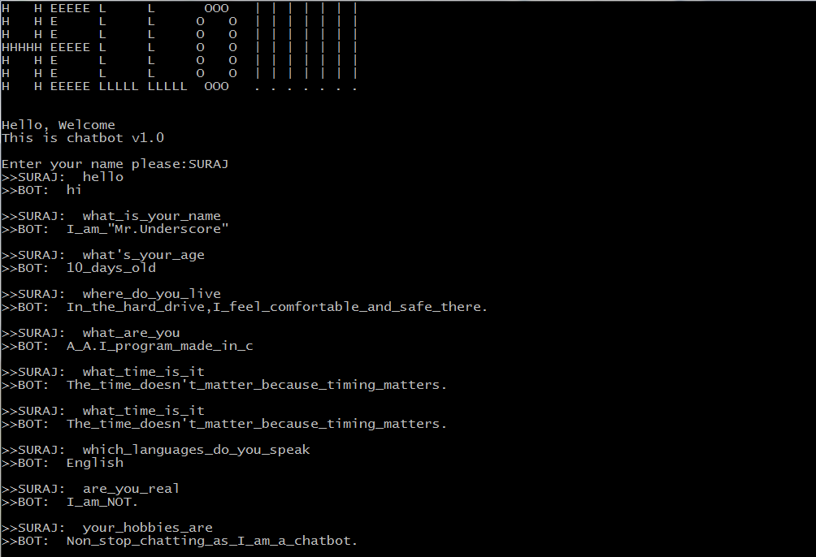

* The above output screen shows the general functioning i.e., answering questions.

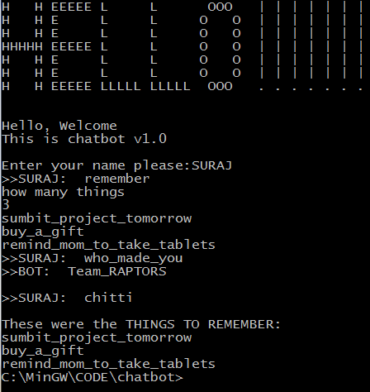

* The above output shows the “reminder” functionality of the chatbot.

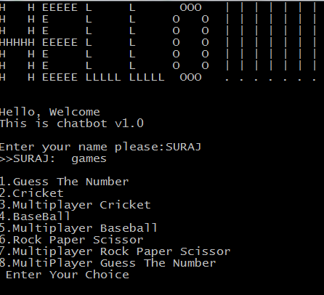

* The above output shows the “Gaming Interface” of the chatbot,

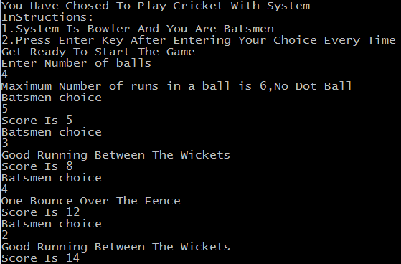

* The above screen is the output of “Hand Cricket” game.
* The below screen shows the output of “Guess the Number” game.

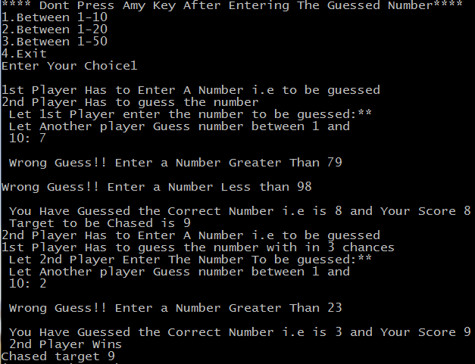

* The below screen shows the output of “Baseball” game.

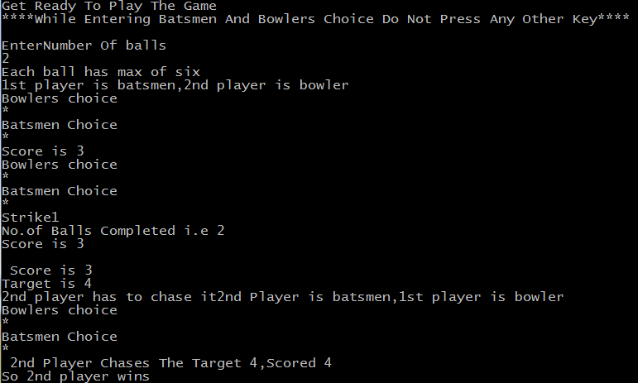

* The bellow screen shows the output of “Rock Paper Scissors” game.

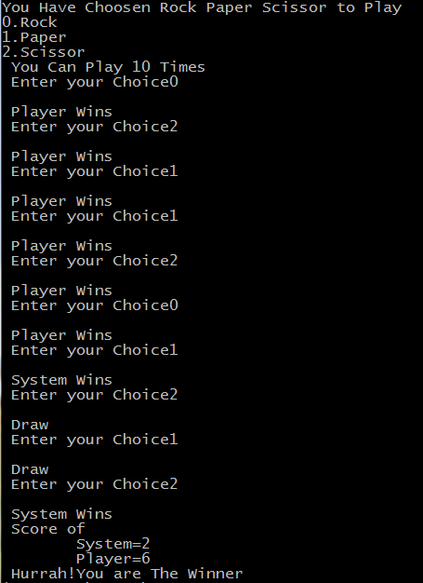

# 6.Conclusion and Future Scope

* Finally we want to conclude by saying that a “Static/pre-defined Chatbot” has been successfully made using ‘C’ language and has got a great scope in the future with the upcoming trends and technologies. These bots are going to be the future.